RESUME OF ENGR/PLNR SYED AKHTAR ALI SHAH
Chairman, Department of Urban and Regional Planning,
University of Peshawar,
shahg@upesh.edu.pk
Ph: 091-9221171
03005901110
03351506147

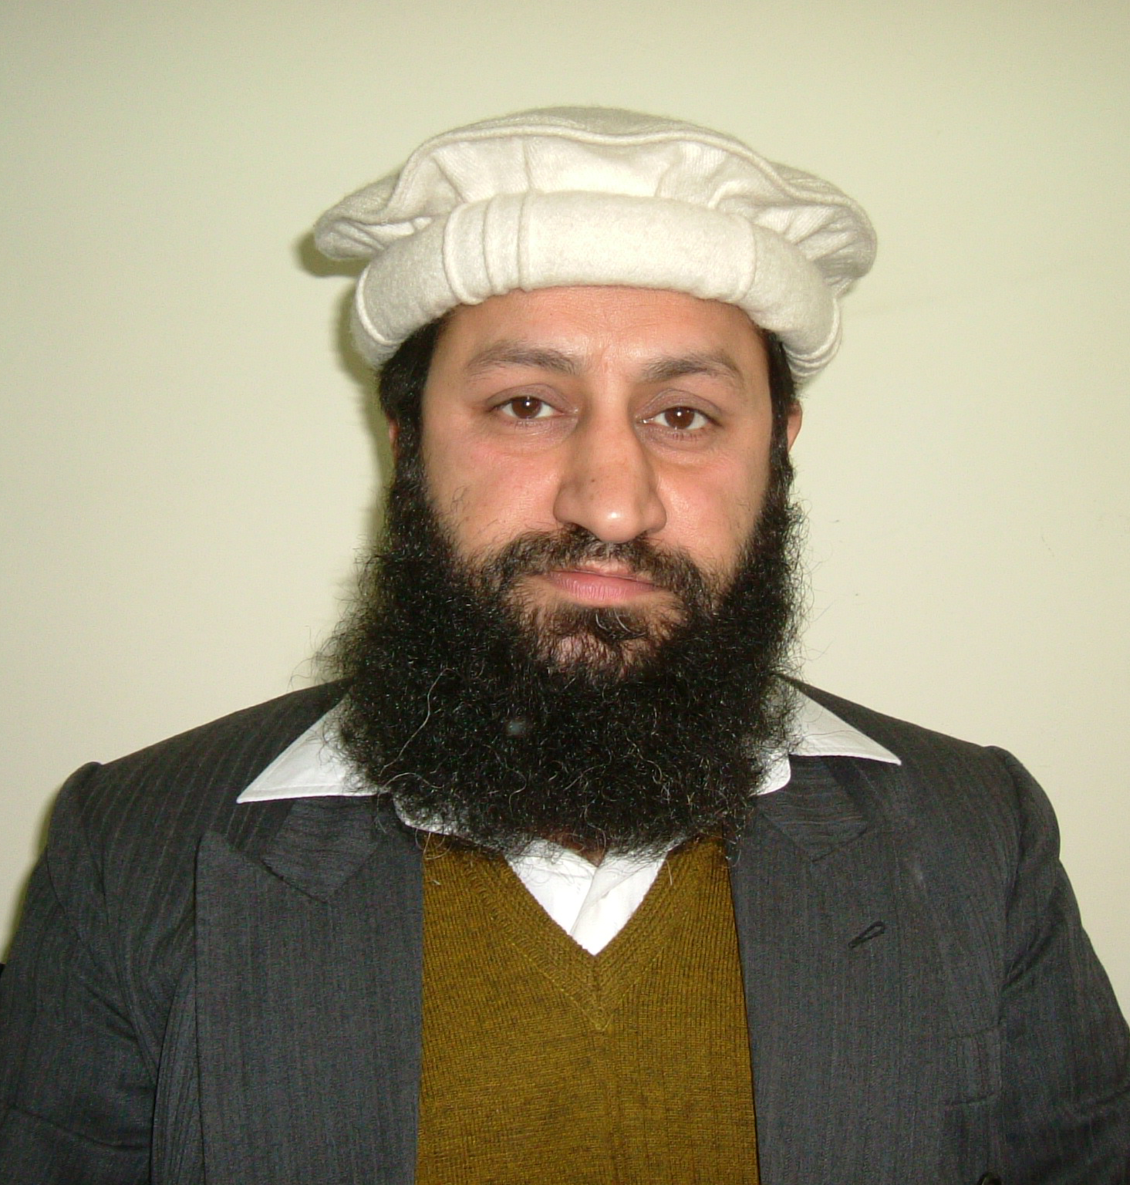

PERSONAL DATA
DATE OF BIRTH: 1965-04-01
DOMICILE Peshawar, Pakistan.
CURRENT EMPLOYER University of Peshawar, Pakistan, 1993-till date
POSITION Associate Professor
POST DOCTORAL EXPERIENCE i) Post-doctoral Research, 2006-7
School of Civil and Environmental Engineering, Yeungnam University South Korea
PROFESSIONAL MEMBERSHIP i) Pakistan Engineering Council (Civ-12790)
ii) Pakistan Council of Architects and Town Planners (P-0748)
DISTINCTIONS/ ACIEVEMENTS

- ODA/British Government Technical Co-Operation Award for post graduate studies 1993-5
- United Nations University/KJIST joint scholarship for PhD studies 2003-4
- Brain Korea (BK-21) Award during PhD studies, 2003-4
- Korea Science and Engineering Foundation (KOSEF) Scholarship award from Korean Ministry of Science and Technology, South Korea 2003-6.
- Best Debater of the UET, Winner All Pakistan Speech contest

Academic background and experience:

I did my graduation in Civil Engineering (1986-90) from UET, Peshawar; Post graduation in Environmental Planning from Institute of Planning Studies, University of Nottingham, UK (1993-95) and PhD from Gwangju Institute of Science and Technology (GIST), South Korea (2003-06). I have worked on a number of projects as a consultant that ranges from town planning, preliminary socioeconomic appraisal for different infrastructure development projects to highway designing and construction.
Responsibilities in provincial Government of Khyber Pakhtunkhwa

Member of the Steering Committee on Mass Transit System Peshawar, Planning and Development Department, Government of Khyber Pakhtunkhwa
Member of the Provincial Reforms Working Group on Transport Government of Khyber Pakhtunkhwa
Member of the Steering Committee on Urban Beautification and Uplift Project, Government of Khyber Pakhtunkhwa
Member of Steering Committee of Urban Policy Unit, Government of Khyber Pakhtunkhwa
Member of Consultant Selection Committee, Government of Khyber Pakhtunkhwa

Specialized Training Course

- INTEGRATED URBAN TRANSPORT AND TOWN PLANNING COURSE FROM 13 TO 17 JUNE 2016 Held at Singapore.
- Application of Geographic Information System (GIS) and Remote Sensing (RS) in Locational Planning for Basic Infrastructure and Services, 1st to 26th February, 1999, International Center for Integrated Mountain Development (ICIMOD), Kathmandu, Nepal
- Traffic Engineering and Monitoring: MSc module at Department of Civil Engineering University of Nottingham, UK. 1994-95 session

Field of Expertise
Urban Transport Planning and Traffic Management, Urban Land use Planning, Environment Planning, Policy Studies, Civil Engineering Works

Research work

6- RELEVANT RESEARCH PUBLICATIONS

- S. Akhtar Ali Shah , Samiullah, Walayat Shah , and Atta-ur-Rahman, (2016) Impact of Terrain Slopes and Aspect on the Natural Regeneration of the Coniferous Forest in the Northern Pakistan - A Case Study of Ayubia National Park, Proceedings of the Pakistan Academy of Sciences: Pakistan Academy of Sciences B. Life and Environmental Sciences 53 (1): 57–64; ISSN: 0377 - 2969 (print), 2306 - 1448 (online)
- Samiullah, Atta-ur-Rahman , S. Akhtar Ali Shah , and Zahid Khan , and Shah Nawaz (2016) Identification of Suitable Sites for Solid Waste Disposal using GIS Multi-criteria Analysis in Peshawar, Pakistan Proceedings of the Pakistan Academy of Sciences: Pakistan Academy of Sciences B. Life and Environmental Sciences 53 (4): 309–321 (2016) ISSN: 2518-4261 (print), ISSN 2518-427X (online)
- Pukhtoon Yar, Atta-ur-Rahman,Mohammad Aslam Khan, Samiullah, S. Akhtar Ali Shah (2016) Spatio-temporal Analysis of Urban Expansion on Farmland and Its Impact on the Agricultural Land Use of Mardan City, Proceedings of the Pakistan Academy of Sciences: Pakistan Academy of Sciences B. Life and Environmental Sciences 53 (1): 35–46 ISSN: 0377 - 2969 (print), 2306 - 1448 (online)
- Maryam Akbar*, Rawid Khan, Syed Akhtar Ali Shah, (2016) Microsimulation of Urban Traffic Flow-A Case Study of University Road Peshawar, Pakistan International Journal of Engineering Sciences & Management Research (ISSN 2349-6193) 3(3) https://www.academia.edu/23397689/
- Muhammad Usman Shafi, Syed Muhammad Ali, Syed Akhtar Ali Shah, Kamran Ahmed (2015) Development of Database of Heavy Truck Load Data in Peshawar, Pakistan, Journal of Engineering and applied Sciences, University of Engineering and technology Peshawar Vol 34 No.1 http://www.uetpeshawar.edu.pk/jeas/jeas34/one/7.pdf
- Zulfiqar Ali, S. Akhtar Ali Shah Anwar Hussain, (2012) Growing Traffic in Peshawar: An Analysis of Causes and Imp acts Journal of South Asian Studies Vol. 27, No. 2, July-December 2012, pp.409-420

Mohmmad Aslam Khan, S. Akhtar Ali Shah, Food Insecurity In Pakistan - Causes and Policy Response Journal of Agricultural and Environmental Ethics, Springer Netherlands, http://www.springerlink.com/content/181512p630687unk/ ISSN: 1573-322X (Online) DOI: 10.1007/s10806-010-9274-2

Mohmmad Aslam Khan, S. Akhtar Ali Shah, Agricultural Development and Associated Environmental and Ethical Issues in South Asia Journal of Agricultural and Environmental Ethics, Springer Netherlands http://www.springerlink.com/content/b097228532133q63/ ISSN: 1573-322X (Online) DOI: 10.1007/s10806-010-9280-4
- Mohmmad Aslam Khan, S. Akhtar Ali Shah (2010), Sustainable Development of Agriculture in South and Central Asian Regions- A Key to Prosperity, Central Asia Journal, issue No. 66, pp1-24, Area Study Center, University of Peshawar, Pakistan
- S. Akhtar Ali Shah, Hojung Kim 2010 System Architecture of the Decision Support System for Freeway Traffic Management employing Microscopic Simulation and Expert System Vol 34(1), pp 37-42 Journal of Science and Technology University of Peshawar, Pakistan
- Yongsung Cho, S. Akhtar Ali Shah, Jong Dal Lee 2009, A retrospective précis of Intelligent Transportation Systems in Korea- Deployment Benefits and Apprehension’s, World Review of Intermodal Transportation Research Vol, 2 Nos. 2/3, pp. 218-233, INDERSCIENCE ENTERPRISES LTD Switzerland ISSN 1749-4729
- S. Akhtar Ali Shah, N.P Mahalik, Byung Ha Ahn, 2009 Strategic Niche Management for the Intelligent Transport Systems deployment and development in developing countries, World Review of Intermodal Transportation Research Vol, 2Nos. 2/3, pp.145-154 INDERSCIENCE ENTERPRISES LTD Switzerland ISSN 1749-4729
- S.Akhtar Ali Shah; Hojung Kim; Seungkirl Baek, PhD; Hyunho Chang; Byung Ha Ahn "System Architecture of A Decision Support System for Freeway Incident Management in Republic of Korea" Transportation Research Part A: Policy and Practice, Volume 42A, pp 799-810 Pergamon-Elsevier Science Ltd UK http://dx.doi.org doi:10.1016/j.physletb.2003.10.071
- Shah, A.A. Dal, L.J., 2007, Intelligent Transportation Systems in Transitional and Developing Countries Aerospace and Electronic Systems Magazine, IEEE, Volume: 22, Issue: 8, pp. 27-33, IEEE-INST ELECTRICAL ELECTRONICS ENGINEERS INC Phoenix, AZ, USA, ISSN: 0885-8985 http://ieeexplore.ieee.org/xpl/tocresult.jsp?isnumber=4300990
- H. Chang, S. Baek, H. Kim, A. A. Shah, J.D. Lee and N. P. Mahalik, 2007, Development of Distributed Real-Time Decision Support System for Traffic Management Centers using Microscopic CA Model, Iranian Journal of Science and Technology, Transaction B, Engineering Vol. 31 No. B2, pp 155-166 Shiraz University, Islamic Republic of Iran. http://www.shirazu.ac.ir/en/files/extract_file.php?file_id=729
- S. Akhtar Ali Shah, Byung Ha Ahn, 2006 , Intelligent transportation system -Is it a compatible tool for developing countries? Journal of Advanced Transportation, Vol 40, No3, pp.289-294, INST TRANSPORTATION, USA ISSN: 2042-3195 http://www.advanced-transport.com/Vol40_no3_3.htm
- S. Akhtar Ali Shah, Kim, Hojung, Yongsung Cho, N.P.Mahalik and Byung Ha Ahn 2005, IT Based Toll Plaza Operation Strategy with ETCS, IETE, Technical review, Vol 22 No 5, September-October 2005, pp 357-365, Institute of Electronics and Telecommunication Engineers (IETE, New Delhi, India www.iete.info/journal_of_ed/technical_review_06.htm
- Kim Hojung, S. Akhtar Ali Shah, Heyonho Jang, and Byung Ha Ahn, (2005) “Microscopic Simulation in Decision Support System for the Incident Induced Traffic Management”, LNCS/LNAI, Part.1, Volume 3681 / 2005, pp. 255-260, Springer-Verlag GmbH, (USA) http://dx.doi.org/10.1007/11552413_37
- Hojung Kim, S. Akhtar Ali Shah, 2008, Freeway Incident Analysis System- validation against microscopic traffic flow characteristics, Vol. 27 Number 3 pp243-248, Mehran University Research Journal of Engineering and Technology, University of Engineering and Technology, Jamshoro Pakistan
- S. Akhtar Ali Shah "Lahore- Islamabad Motorway Project” Pakistan Journal of Geography, Vol. IX & X, Number 1 & 2, University of Peshawar. June-December 1999-2000 pp 115-8, (Pakistan)

b) Conferences

- Numan Ahmad; Anwaar Ahmed; Akhtar Ali Shah (2017) Is Effective Enforcement of Seatbelt Law Helpful in Reduction of Road Traffic Fatalities: A Global Perspective- Fifth International Conference on Infrastructure Engineering in Developing Countries (IEDC-2017) JULY 14 & 15, 2017
- S. Akhtar Ali Shah
- S. Akhtar Ali Shah, Hojung Kim (2011) System Architecture of the Decision Support System employing Microscopic Simulation and Expert System in parallel for the Post Incident Traffic Management, in the Proceedings of 13th International Conference on Enterprise Information Systems of 2011 (ICEIS'2011) Beijing, China, 8-11 June, 2011.
- Akhtar Ali Shah, N. P. Mahalik, J. Namkoong & J. D. Lee, 2006 Intelligent transportation-deployment and development process in Korea in the Proceedings of Urban Transport XII Urban Transport, and the Environment in the 21st Century, Praugue, 12-14 July 2006, pp.763-772, ISBN 1845641795
- S. Akhtar Ali Shah, Jong Dal Lee, “Intelligent Transportation and Developing Countries – How far can we go and How?” 1st Middle East Conference & Exhibition on Intelligent Transport Systems, 4-5 December 2006, Dubai, UAE
- S. Akhtar Ali Shah, Jong Dal Lee “Intelligent Transportation Systems in Transitional and Developing Countries” in the proceedings of 1st International Conference on Advances in Space Technologies, 2-3 September, 2006 Islamabad, Pakistan, pp: 54-59, Print ISBN: 1-4244-0515-7
- S Akhtar Ali Shah, J. Namkoong, N.P. Mahalik, A. Byung Ha 2005 Intelligent transportation: Realizing the benefits - A case study of Korea Sustainable Development & Planning 2005 Second International Conference on Sustainable Development & Planning 12 - 14 September 2005 Bologna, Italy
- S. Akhtar Ali Shah, Kim Ho-Jung, Hyunho Chang, Seungkirl Baek, Ahn, Byung Ha , 2005 Incident Impact Forecasting for non-recurrent freeway traffic management, International Symposium on Management, Engineering and Informatics: MEI '05 July 24-27, 2005 in the Proceedings the 3rd International Conference on Computing, Communications and Control Technologies, Austin, Texas, USA pp. 252-257
- S. Akhtar Ali Shah, Hojung Kim and Byung Ha Ahn 2005, Post-incident decision support system for freeway incident analysis and traffic management In Proceedings of The 7th Asia Pacific ITS Forum & Exhibition, August 9-11, 2005 New Delhi, India
- S. Akhtar Ali Shah, Seungkirl Baek, Hyunho Chang Hojung Kim, and Byung Ha Ahn, 2005 Application Of Dynamic Simulation Model for Non-Recurrent Traffic Management in the proceedings of Asia Simulation conf./The Sixth International Conference on System Simulation and Scientific Computing (ICSC’2005) Beijing, P.R.China, pp. 1457-1461
- Kim Ho-Jung, S. Akhtar Ali Shah, Seungkirl Baek, Ahn, Byung Ha, 2004Architecture of decision support system for freeway incident analysis using microscopic simulation –A case study of Republic of Korea. In (CD ROM) Proceedings of 11th World Congress on ITS, Nagoya, Japan
- S. Akhtar Ali Shah, 1996, Traffic Congestion in Peshawar, 8th All Pakistan Geographical Conference, April 7-10, 1996 Peshawar Pakistan
- S. Akhtar Ali Shah 1999, Urban Land Zonation, Is it an Appropriate Approach for Developing Economies, International Conference on Sustainable Management of Natural Resources, 1-6th December 1999, UNESCO-University of Peshawar collaboration, Peshawar Pakistan

8- SUMMARY OF WORK EXPERIENCE
i) Employment Record

- institute of Geography, Urban & Regional Planning University of Peshawar; from March 1993 June 2014
- Department of Urban & Regional Planning University of Peshawar; from June 2014 till date.
- M/S Allai Khawr Consultants, Peshawar Cantt., Pakistan; April 1997 till June 1997 (part time).
- Urban Planner/ Transport Planner at M/S GHK International Ltd.(United Kingdom) /FAC consultant, PMU, PDA, Hayatabad, Peshawar; from Jun 1996 to August 1996 (part time).
- Road Engineer/Planner M/S Khyber Consulting Engineers, Hayatabad Peshawar, Pakistan; from October 1990 to August 1992.
- Site Engineer M/S Karcon (Private) Limited. G.T. Road Peshawar, Pakistan; from November 1989 to October 1990.

ii) Description of Duties

- University of Peshawar: Teaching of Urban Transport Planning and Traffic Management; Intelligent Transport Systems, Land Use Planning; Policy studies, Geographic Information System, Urbanization and Urban Planning
- School of Civil Environment and Urban Studies, Yeungnam University, Republic of Korea, Teaching and Research in Transport Planning, Land Survey and GIS related fields
- GHK/FAC Consultants: Study the impacts of Peshawar Ring Road on land developments in Peshawar.
- M/S Allai Khawr Consultant: Preliminary cost estimation of about 42 kilometers of unmetalled Access road to a dam site on Chore Nala in District Kohistan.
- M/S Khyber Consulting Engineers: Geometric and structure design of roads in different districts of NWFP, data processing, date analysis, quantity estimation for roadwork, field surveys etc.
- M/S Karcon (pvt) Ltd: Supervision of road construction and widening work at Jamrud road. Measurement and quantity estimation, surveying and leveling.

- Research/ Project Experience
- Master Planning of Almasa Township, Warsak Road Peshawar, M/S Daecon Consultants, Peshawar
- Master Planning of University Town Nasir Bagh Road Peshawar M/S Frontier Associates, Peshawar
- Citizen Community Boards (CCBs); Citizen Participation for Human Rights and Public Service delivery at Grassroots level in Pakistan conducted by M/S CIET international and National Reconstruction Bureau (NRB) Govt. of Pakistan,
- Design of physical infrastructure and utility services of an 88 acres private township scheme in Peshawar.
- Preparation of Technical proposal for an Educational Township Scheme of 2000 acres near Islamabad, Pakistan, 2001
- Baseline survey of District Abbottabad and Bannu for Institutional Reforms Program- A socio-economic Study conducted by UNDP and Governance Unit PE&DD GoNWFP, 1999.
- Developed Technical proposal for Land use planning and zoning, conducted by PE&D Department, Govt of NWFP,1998.
- Preparation of a Regional Development Plan for Peshawar District based on participatory approach, Students’ project
- Geometric/ Environmental alignment of 42 km Chore Nala Hydro Power Station Access road, Bisham, for SHYDO/ Allai Khwar Consultants1997.
- Impacts of Peshawar Ring Road on Land Development, real estate prices in the vicinity for Project Management Unit /GHK/FAC 1996
- Alignment of about 200 kilometer rural roads in district Dir, Bannue, D.I. Khan and Kohat based on Social, Environmental and technical standards. Preparation of PC-I for the above mentioned road projects. On behalf of M/S Khyber Consulting Engineers (KCE) for LG&RDD Govt of NWFP, 1990-1992
- Infrastructure Planning and location in Kanju Township, (Phase I) Mingora Swat, On behalf of M/S Khyber Consulting Engineers (KCE) for LG&RDD Govt of NWFP, 1990-1991
- Realignment of the part of Ring Road Peshawar (Southern section), Peshawar Development Authority, PUDB, Govt of NWFP, 1990-1991

iv) Supervisory Experience

- University of Peshawar: Supervised different dissertations of the student of MSc/Mphil Urban and Regional Planning, Geography on various aspects of Environment and planning including Transport, Regional, Land use, infrastructure, Good governance and NRM
- GHK/FAC Consultants: supervised a team of social scientist for conducting socio-economic survey in the Study area.
- M/S Allai Khawr Consultant: Team of road engineers, land surveyors, quantity estimators and computer operators
- M/S Khyber Consulting Engineers: supervision of a team of engineers land surveyors, architects and other office administrators
- M/S Karcon (pvt) Ltd: Supervision of Jamrud Road construction and widening

REFERENCES

Prof Dr Lee Jongdal
School of Civil and Environmental Engineering
Yeungnam University, Republic of Korea
Mobile : +82-16-663-2416; Office : +82-53-810-2416
FAX : +82-53-810-4622
Email: jdlee@ynu.ac.kr

Prof. Dr Akhtar Naeem Khan
Department of Civil Engineering
University of Engineering and technology
Peshawar

Prof. Dr Rasul Jan,
Vice Chancellor University of Peshawar
Peshawar, Pakistan
Ph:++92-919210701 Ext: 3001
vice_chancellor@upesh.edu.pk

